 Methods Unit 4 Test 5, 2016

(Calculator Free) Name__________________

Time: 17 minutes Marks: 17

1. [1, 1, 2, 2 marks]

Using the 68%, 95%, 99.7% rule, determine the following probabilities:

1. P(-2 < X < 2) where XN(0, 12)
2. P(X < 1) where XN(0, 12)
3. P(X < 8) where XN(10, 22)
4. P(X > 35) where XN(20, 52)

2. [2, 2, 1, 2 marks]

A football club has 1 200 members. Their ages are indicated below:

|  |  |  |  |  |  |
| --- | --- | --- | --- | --- | --- |
| Age | 10 - 19 | 20 - 29 | 30 - 39 | 40 - 49 | 50+ |
| Number | 256 | 309 | 360 | 155 | 120 |

1. A sample of 60 members are to be surveyed about a change to the design on the Club jumper. The president uses an alphabetic list of members and selects every 20th member. Outline two reasons why this method may introduce bias.

continued next page……

1. Suggest another way this sample could be chosen such that it is more representative of the ages of members.
2. How many members over 50 years of age should be included in the sample?

1. Describe how you would select these members that are over 50 years old using your Classpad’s ability to generate random numbers.

3. [4 marks]

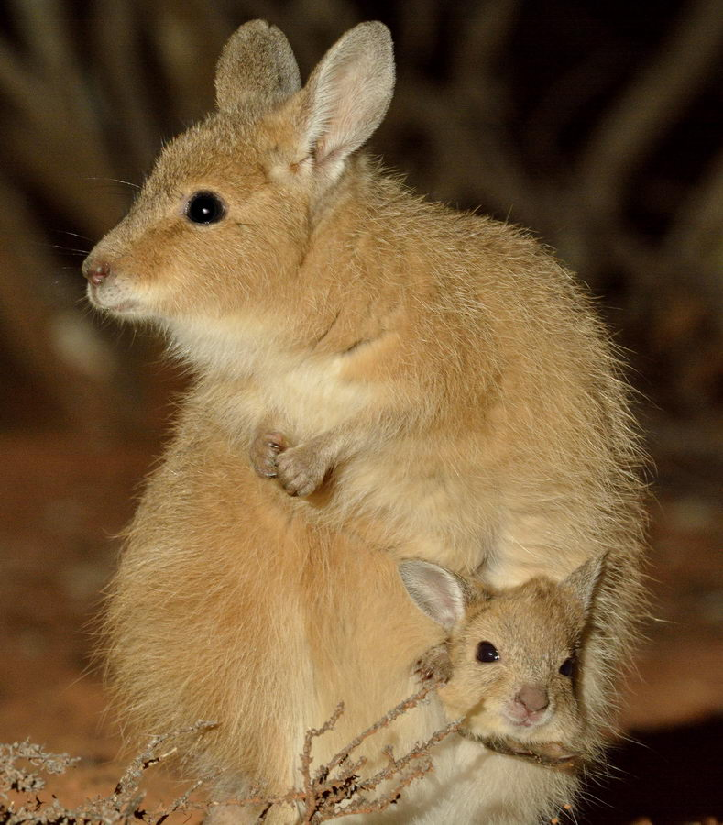The rufous hare-wallaby, also known as the mala, was formerly widely distributed across the western half of the continent but is now confined to [Bernier Island](https://en.wikipedia.org/wiki/Bernier_Island) and [Dorre Island](https://en.wikipedia.org/wiki/Dorre_Island) off the [Western Australia](https://en.wikipedia.org/wiki/Western_Australia)n coast. It is currently classified as vulnerable.

In order to determine how many mala there are on each of these islands, conservationists catch and tag 21 animals on each island.

When they return to Bernier and capture 20 animals, they find 3 of these are tagged.

They return to Dorre and capture 10 animals, and 1 of these is tagged.

Estimate the number of mala in total.



Methods Unit 4 Test 5, 2016

(Calculator Assumed) Name___________________

Time: 35 minutes Marks: 35

4. [4 marks]

In a given normal distribution, P(x < 50) = 0.6

If the mean of this distribution is 48, determine the standard deviation, correct to 1 d.p.

5. [1, 1, 2, 2, 2, 2 marks]

The weight of eggs packaged by OzzieFresh are normally distributed with a mean of 50g and standard deviation of 4g.

1. What is the probability that an egg, chosen at random, will weigh more than 52g?
2. What is the probability that an egg, chosen at random, will weigh between 45g and 55g?
3. The heaviest 1% of eggs are called Jumbo and sold to restaurants. What is the minimum weight of an egg (to the nearest gram) for it to be called a Jumbo?
4. Ten eggs are chosen at random. What is the probability that they all weigh between 45g and 55g?
5. A further six eggs are chosen at random. What is the probability that at least 3 will weigh more than 52g?
6. A student wishes to simulate choosing 10 eggs (and recording their weight) using his calculator. He uses RandList(10, 40, 60) to do this. Comment on his method.

6. [2, 2, 3 marks]

1. For a sample of size 200 and a sample proportion of 0.3, determine the margin of error at the 99% confidence level.
2. Write the confidence interval

c) Suppose we wished the margin of error to be 0.1 instead of your answer above. Determine the required sample size.

7. [1, 2, 3 marks]

A survey is carried out to investigate the number of female teachers in Western Australian primary schools. In a survey of 1500 teachers, 969 are female.

a) Calculate the sample proportion $\hat{p}$ of the teachers surveyed who were female.

b) Estimate the standard deviation of $\hat{p}$.

c) According to the Department of Education, the proportion of female teachers in WA primary schools is 70.1%. Comment on the survey results.

8. [5 marks]

A set of data has the following statistics:

Mean = 40 Median = 39 Standard deviation = 15.5 Lower quartile = 29 Upper quartile = 50

Maximum value = 86

State, with reasoning whether this summary of statistics suggests the data is normally distributed.

9. [3 marks]

A student creates a spinner where the long-term proportion of even numbers is 0.7

After 50 spins the student assumes that the sample distribution will approximate a normal distribution. Is she justified in making this assumption? Explain your answer.